Advanced Smart Mobile

Pronckutė, Edita E.

Fontys UAS

Advanced Smart Mobile

UX analysis of EnWB mobility+ mobile app

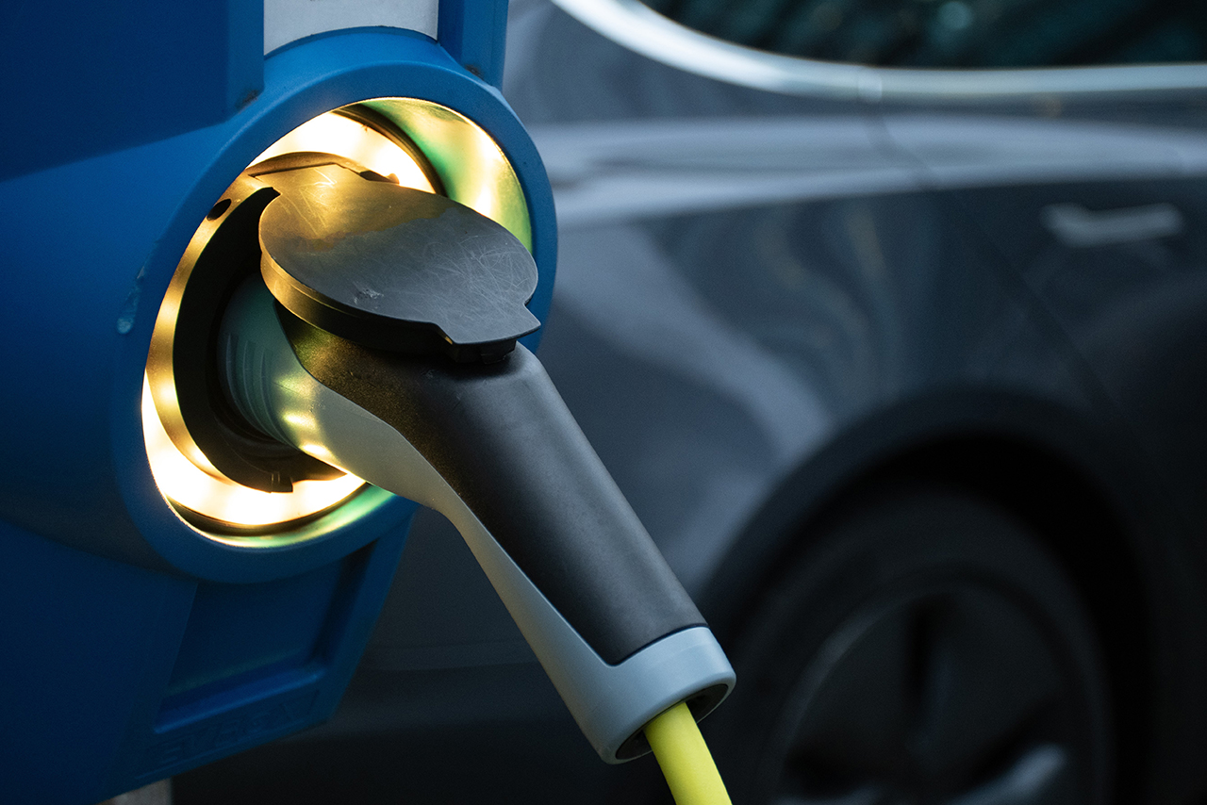

Contents

About 2

The 5 dimensions of Interaction Design 3

7 Factors Describing User Experience 5

References: 7

# About

EnBW mobility+ is the smart all-in-one solution for an Electric Vehicle (EV) copilot offers three functions in one app:

* Searching charging stations nearby
* Charging and payment
* Taking EVs for virtual test drives

**Charging Stations Locator**

The main use of the application is the nearest charging station locator. There is a widespread network of EnBW chargers and roaming partners in various European countries (Germany, Austria, Switzerland, France, Italy, Netherlands etc.). In addition, users can save or mark charging stations, see their availability and conveniently navigate to them using google map integration.

**Charging and Payment**

EnBW mobility+ app enables users to conveniently start the charging process and even pay directly via your smartphone. Users can monitor their charging progress and stop the charging once they have enough energy. Moreover, the charging history and costs can be reviewed and checked at any time.

**Test driving any EV**

For the users interested in a new EV, there is an option to virtually test drive an EV of their liking. They can choose from a comprehensive pool of all currently available EVs to simulate a preferred EV drive with their conventional car make in-depth comparisons of different vehicles and how they match their profile.

# The 5 dimensions of Interaction Design

The 5 dimensions of interaction design(1) is a useful model to understand what interaction design involves. Gillian Crampton Smith, an interaction design academic, first introduced the concept of four dimensions of an interaction design language, to which Kevin Silver, senior interaction designer at IDEXX Laboratories, added the fifth.

**1D: Words**

Words—especially those used in interactions, like button labels—should be meaningful and simple to understand. They should communicate information to users, but not too much information to overwhelm the user.

**2D: Visual representations**

This concerns graphical elements like images, typography and icons that users interact with. These usually supplement the words used to communicate information to users.

**3D: Physical objects or space**

Through what physical objects do users interact with the product? A laptop, with a mouse or touchpad? Or a smartphone, with the user’s fingers? And within what kind of physical space does the user do so? For instance, is the user standing in a crowded train while using the app on a smartphone, or sitting on a desk in the office surfing the website? These all affect the interaction between the user and the product.

**4D: Time**

While this dimension sounds a little abstract, it mostly refers to media that changes with time (animation, videos, sounds). Motion and sounds play a crucial role in giving visual and audio feedback to users’ interactions. Also of concern is the amount of time a user spends interacting with the product: can users track their progress, or resume their interaction some time later?

**5D: Behavior**

This includes the mechanism of a product: how do users perform actions on the website? How do users operate the product? In other words, it’s how the previous dimensions define the interactions of a product. It also includes the reactions—for instance emotional responses or feedback—of users and the product.

**Some important questions interaction designers ask when designing for users, as provided by Usability.gov:**

* What can a user do with their mouse, finger, or stylus to directly interact with the interface? This helps us define the possible user interactions with the product.
* What about the appearance (colour, shape, size, etc.) gives the user a clue about how it may function? This helps us give users clues about what behaviours are possible.
* Do error messages provide a way for the user to correct the problem or explain why the error occurred? This lets us anticipate and mitigate errors.
* What feedback does a user get once an action is performed? This allows us to ensure that the system provides feedback in a reasonable time after user actions.
* Are the interface elements a reasonable size to interact with? Questions like this helps us think strategically about each element used in the product.
* Are familiar or standard formats used? Standard elements and formats are used to simplify and enhance the learnability of a product.

# 7 Factors Describing User Experience

**Useful**

If a product isn’t useful to someone, why would you want to bring it to market? If it has no purpose, it is unlikely to be able to compete for attention alongside a market full of purposeful and useful products. It’s worth noting that “useful” is in the eye of the beholder and things can be deemed “useful” if they deliver non-practical benefits such as fun or aesthetic appeal.

Thus a computer game or sculpture may be deemed useful even if they don’t enable a user to accomplish a goal that others find meaningful.

**Usable**

Usability is concerned with enabling users to effectively and efficiently achieve their end objective with a product. A computer game which requires 3 sets of control pads is unlikely to be usable as people, for the time being at least, only tend to have 2 hands.

Products can succeed if they are not usable, but they are less likely to do so. Poor usability is often associated with the very first generation of a product – think the first generation of MP3 players, which lost their market share to the more usable iPod when it was launched. The iPod wasn’t the first MP3 player, but it was the first truly usable MP3 player.

**Findable**

Findable refers to the idea that the product must be easy to find and in the instance of digital and information products; the content within them must be easy to find too. If you cannot find a product, you’re not going to buy it and that is true for all potential users of that product.

If you picked up a newspaper and all the stories within it were allocated page space at random, rather than being organized into sections such as Sport, Entertainment, Business, etc. you would probably find reading the newspaper a very frustrating experience. Findability is vital to the user experience of many products.

**Credible**

Randall Terry said, “Fool me once, shame on you. Fool me twice, shame on me.” Today’s users aren’t going to give you a second chance to fool them – there are plenty of options in nearly every field for them to choose a credible product provider.

Credibility relates to the ability of the user to trust in the product that you’ve provided. Not just that it does the job that it is supposed to do but that it will last for a reasonable amount of time and that the information provided with it is accurate and fit-for-purpose.

It is nearly impossible to deliver a user experience if the user thinks the product creator is a lying, clown with bad intentions – they’ll take their business elsewhere instead.

**Desirable**

Skoda and Porsche both make cars. They are to some extent both useful, usable, findable, accessible, credible and valuable but Porsche is much more desirable than Skoda. This is not to say that Skoda is undesirable they have sold a lot of cars under that brand but given a choice of a new Porsche or Skoda for free – most people will opt for the Porsche.

Desirability is conveyed in design through branding, image, identity, aesthetics and emotional design. The more desirable a product is – the more likely it is that the user who has it will brag about it and create desire in other users.

**Accessible**

Sadly, accessibility often gets lost in the mix when creating user experiences. Accessibility is about providing an experience which can be accessed by users of a full range of abilities – this includes those who are disabled in some respect such as hearing loss, impaired vision, motion impaired or learning impaired.

Design for accessibility is often seen by companies as a waste of money because the impression is that people with disabilities make up a small segment of the population. In fact, in the United States at least 19% of people have a disability according to the census data and it is likely that this number is higher in less developed nations.

That’s 1 in 5 people in the audience for your product that may not be able to use it if it’s not accessible or 20% of your total market!

It’s also worth remembering that when you design for accessibility, you will often find that you create products that are easier for everyone to use not just those with disabilities. Don’t neglect accessibility in the user experience.

Finally, accessible design is now a legal obligation in many jurisdictions including the EU and failure to deliver it may result in fines. Sadly, this obligation is not being enforced as often as it should be.

**Valuable**

Finally, the product must deliver value. It must deliver value to the business which creates it and to the user who buys or uses it. Without value it is likely that any initial success of a product will eventually be undermined.

Designers should bear in mind that value is one of the key influences on purchasing decisions. A $100 product that solves a $10,000 problem is one that is likely to succeed; a $10,000 product that solves a $100 problem is much less likely to do so.

**Conclusion**

The success of a product depends on more than utility and usability alone. Products which are usable, useful, findable, accessible, credible, valuable and desirable are much more likely to succeed in the market place.

# References:

<https://www.interaction-design.org/literature/article/what-is-interaction-design>

<https://uxplanet.org/interaction-design-a-guide-for-beginners-32ff2364b53f>

<https://www.interaction-design.org/literature/article/the-7-factors-that-influence-user-experience>